CURRICULUM-VITAE

PROFESSIONAL BIOGRAPHY | 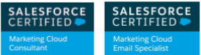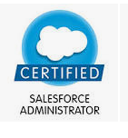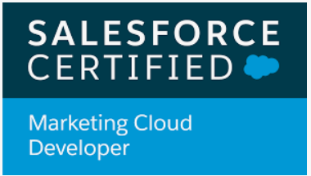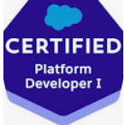
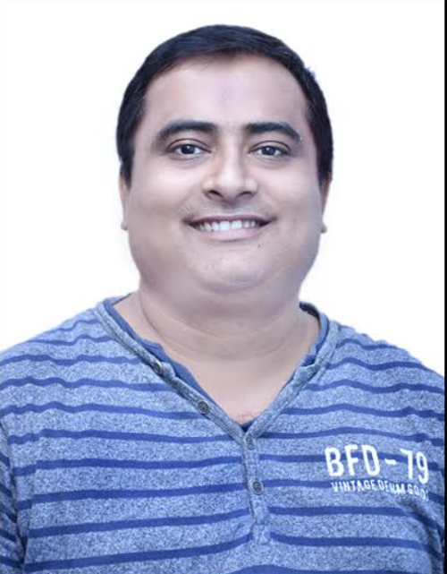 | Name: NIRAJ KUMAR SHUKLA  Role: Sales force Marketing cloud Architect/Consultant/Developer  Contact No: +918447226776 ,+919026727894  Email id: niraj_shukla2000@yahoo.com

Profile Summary

- 15 + years of Industry experience with almost 8 years’ experience in Salesforce Marketing cloud & holding 5 major Salesforce certification.
- Salesforce certified Email specialist, Developer, Consultant and CRM admin,Pd1 developer.
- Good working knowledge of Salesforce Classic (PAAS), Salesforce Marketing cloud, Sales cloud, Service cloud.
- Working as Team Lead for a leading publication house handling marketing cloud.
- Experience of co-ordination between offshore and onsite model.
- Technical expertise in Software development lifecycle stages like requirements gathering, analysis, design, development, testing, deployment and support.
- Experienced in Impact Analysis, Effort estimation.
- Experience in B2B Lead generation campaigns using tools like CloudCraze, Pardot etc. Using these tools the system was successfully able to create seamless interactions across commerce, sales, marketing, and service for a 360-degree view of data that’s 100 percent connected to the customer.

Technical skills

Technical Expertise And TOOLS

Business Area: Salesforce Marketing Cloud, Salesforce Classic, Salesforce Pardot, Sales cloud, Service cloud,
CRM: Salesforce.com
Languages: Ampscript, SSJS,JavaScript
Trainings attended: Salesforce CRM,Salesforce Marketing cloud
Database(s):SQL Server
ETL(s): Mulesoft

Education:
  - MCA from PTU

Certifications

Salesforce Certified Marketing Cloud Consultant.

Salesforce Certified Email Specialist.

Salesforce Certified CRM Admin.

Professional Journey Salesforce Marketing Cloud

Company Name : CloudSmiths Period : 12-01-2022 till present

Some Project Details

Project Name: University of the Witwatersrand, Johannesburg
Period: Jan 2022 to Present

Role: Sales force Marketing Cloud Architect

•
Responsibilities:

- Handling development and design Of Email and mobile campaigns
- Designed data architecture of cloud and cross platform integration of cloud with other systems like sales cloud and Pardot.
- Working as sales force marketing cloud admin task taking care of creation and assignment of roles and permissions to users with in Informa enterprise.
- Implementation of marketing cloud connect and multi org within the enterprise to achieve independent integration goals for each business unit.
Technologies & Tools: Salesforce Marketing cloud, SSJS

Company Name : Cognizant India Period : 06-2021 to 10-01-2022

Some Project Details

Project Name: Sydney Markets Limited
Period: Jun 2021 to Present

Role: Sales force Marketing Cloud Architect

•
Responsibilities:

- Handling development and design Of Email and mobile campaigns
- Designed data architecture of cloud and cross platform integration of cloud with other systems like sales cloud and Pardot.
- Working as sales force marketing cloud admin task taking care of creation and assignment of roles and permissions to users with in Informa enterprise.
- Implementation of marketing cloud connect and multi org within the enterprise to achieve independent integration goals for each business unit.
Technologies & Tools: Salesforce Marketing cloud, SSJS

Company Name : Girikon Solutions Period : 08-2017 to 06-2021

Some Project Details

Project Name: Informa Global

Period: Aug 2017 to dec 2017

Role: Salesforce Technical Architect

Description: Project is about development of Salesforce Marketing cloud campaign development and management.

Responsibilities:

- Handling development and design Of Email and mobile campaigns
- Designed data architecture of cloud and cross platform integration of cloud with other systems like sales cloud and Pardot.
- Working as sales force marketing cloud admin task taking care of creation and assignment of roles and permissions to users with in Informa enterprise.
- Implementation of marketing cloud connect and multi org within the enterprise to achieve independent integration goals for each business unit.

Technologies & Tools: Salesforce Marketing cloud, Salesforce crm, Pardot

Project Name: Taylor and Francis Global
Period: Dec 2017 to Jun 2021
Role: Salesforce Marketing Cloud Developer/Consultant
Description: create marketing campaigns and manage it
Responsibilities:
- Handling integration of marketing cloud with Pardot and salesforce CRM.
- Design data architecture for movement of data to and from marketing cloud.
- Design and development of custom preference center as per the requiring of business using Amp script/SSJS.
- Creation of mail able data Extensions to be used for creation of Campaigns as per the requirement of business.
- Provide training to internal staff/Super users about new changes online/offline on regular basis.

- Creation of data relationships between these mailable data extensions so that marketing employees can segment them as per requirement.
- Creation of highly personalized Emails to be used for various campaigns using Amp script/SSJS and HTML as per Business requirement.
- Design, development, and implementation of complex campaigns targeting audience count of between 100 to 6 million subscribers using journey builder and automation studio.
- Maintain, update, Analyze the data of campaigns developed and refine the campaign as per sales feedback till the target is met.
- Creation of custom api solution using MuleSoft to push data in and out of salesforce, marketing cloud and Pardot.
- Creation of landing pages to be used for gathering subscriber data via online campaigns, seminars and websites using php, javascript, Jquery Ajax, and ampscript.
- Handled migration of data from classic content to content builder/Cloud pages and Trained internal employees on its usage.

Technologies & Tools: Salesforce Marketing cloud, Salesforce CRM, Pardot

Project Name: Resolution Health Center (US)

Period: October 2018 to March 2019
Role: Salesforce Marketing Cloud Consultant

Responsibilities:

•
- Created two campaigns to target sales audience who are interested in their medical solution and products.

- Creation, design and implementation of live Sandbox within the system for testing and training purpose.

Technologies & Tools: Salesforce Marketing cloud, SSJS

Project Name: United Airlines
Period: March 2019 to October 2020

Role: Sales force Marketing Cloud Consultant
Responsibilities:

•
- Created five campaigns to target sales and to send notifications on various client scenarios like ticket purchase, flight.

- Creation, design and implementation of live Sandbox within the system for testing and training purpose.

Technologies & Tools: Salesforce Marketing cloud, SSJS

Project Name: Dolce & Gabbana
Period: October 2020 to Jan 2021

Role: Sales force Marketing Cloud Consultant

Responsibilities:

•
- Created campaigns to target sales and to send notifications on various client scenarios like new product launch promotion, abandon cart revenue generation.
- Created and maintained the customer preference center giving customers choice to opt-in and opt out from various campaign.

Technologies & Tools: Salesforce Marketing cloud, SSJS

Company Name : Pisoftek ltd Period : 10-2014 to 07-2017

Some Project Details

Project Name: Salesforce Inc
Period: Nov 2014 to Jul 2017

Role: Sales force Marketing Cloud Support Consultant/Developer
Responsibilities:

•
- 2.5 years with pisoftek limited as team lead handling Salesforce customers on Salesforce Marketing Cloud taking care of Applications like Journey builder, Automation Studio, Mobile connect and other Email and mobile application’s involving HTML, SQL server 2010 and API. Carrying experience in creating and editing campaigns regarding email and mobile campaigns. Responsible for creating and maintaining email marketing campaigns to promote a product or service.
- Created Campaigns for most of the reputed salesforce premier and platinum clients like Bank of America, Citibank, Dominos, RBS, Epson, Dell, Hp etc.

Some of Projects with various clients under Salesforce

Project Name: Bank of America

Responsibilities:

•
- Created seven campaigns to send notifications on various client scenarios like ticket purchase, flight.

- Creation, design and Maintenance of live production account within the system for testing and training purpose.

Project Name: Dominos

Responsibilities:

•
- Created weekend sale campaign to target customers and and increase revenue.
- Created abandon cart campaign for customers converting leads to sales.

Technologies & Tools: Salesforce Marketing cloud, SSJS

Professional Journey Application support and development

Company Name : Competent Support helpline Period : 07-2013 to 07-2014

- 13 months with supporthelpline.net as senior technical support engineer and Team Lead Handling application support and os troubleshooting.

Company Name : Iyogi Technical services Period : 03-2012 to 06-2013

- 15 Months as technical sales executive Handling application support along with upselling targets

Company Name : Vodafone Period : 11-2010 to 02-2012

- 16 Months as IT executive with Vodafone India pvt ltd. handling service desk UK. (Application support and DC activities) since November 2010. Experience on BMC remedy 7.5, 7.1, 6.0 and handling applications on servers like citrix.

Company Name : Ach and research center Period : 09-2007 to 03-2010

- providing support and training on Products using Java, Jsp, HTML.

Experience history (In brief):

SR NO | Name Of Company | Designation | Tenure
1 | Cloud Smiths | Marketing cloud Architect | jan22-present
1 | Cognizant | Manager Projects | Jun 21 -jan21
2 | Girikon Technologies Pvt Ltd | Team Lead | aug 2017 - jun 21
3 | Pisoftek Ltd | Group Lead | oct 2014 - jul 2017
4 | Competent Support helpline Pvt ltd | Team Lead | jul 2013-jul2014
5 | Iyogi Technical services Pvt Ltd | Executive | mar 2012-jun2013
6 | Vodafone India Pvt Ltd | Executive | nov 2010 - feb 2012
7 | Ach And research center | Trainer | sept2007-mar 2010

Education Qualification:
Master of Computer Applications

Class | Board | Division
10th | C.B.S.E. Board | First
12th | C.B.S.E. Board | First
Graduation (B.A.) | IGNOU | Second
‘A’ Level | DOEACC | First
M.Sc. IT | PTU | First
MCA | PTU | First

